**Design Brief**

**Technological Effect on Sleep and Learning Behaviour’s**

By Lachlan Harrison

Mind Maps:

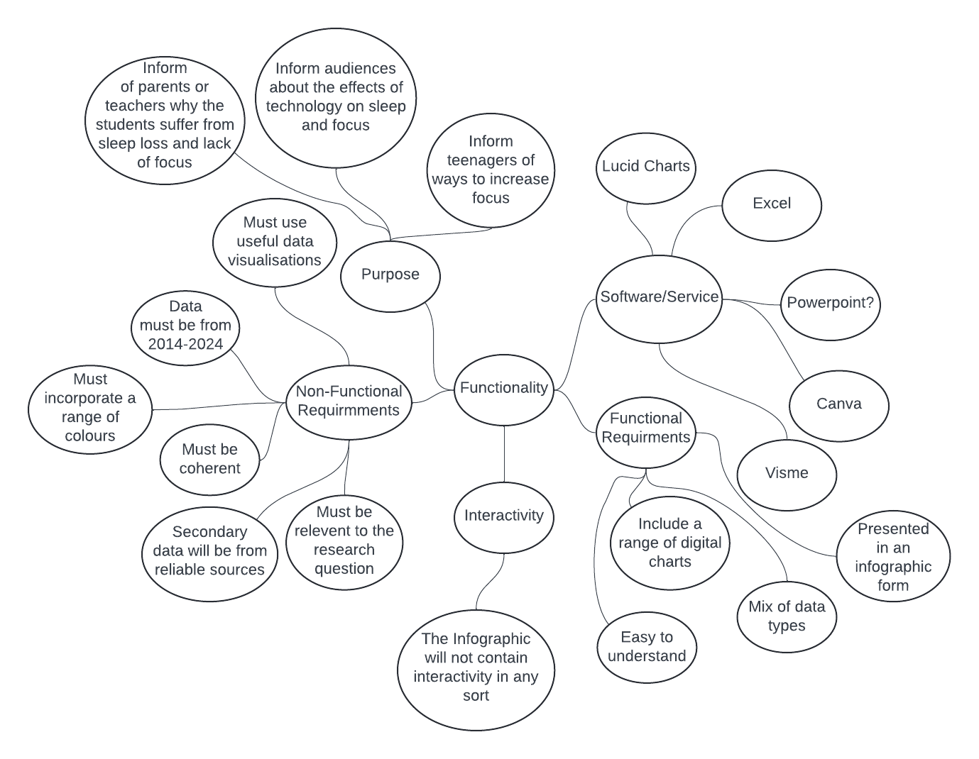

Evaluation Criteria:

|  |  |
| --- | --- |
| **Measure:** | **Evaluation Criteria: Data Analytics** |
| Cost | Does the secondary data collected cost no money to acquire? |
| Readability | Is the font choice easy to interpret? |
| Readability | Is the infographic easy to understand and make sense out of? |
| Attractiveness | Does the chosen colour theme of the infographic help keep the reader focused? |
| Attractiveness | Is the infographic easy for the reader to navigate through? |
| Accuracy | Is all the information/data used through the infographic accurate? |
| Accuracy | Is all the information/data used throughout the infographic from trusted sources? |
| Relevance | Is all the information within the infographic relevant to the research question? |
| Relevance | Do all the data visualisations relate to the topic and information? |
| Communication of Message | Are the data visualisations easy to understand and clear to the reader? |
| Time | Will the infographic be finished in the required time frame? |
| Usability | Does it take limited effort for the reader to navigate throughout the infographic? |

IPO Charts:

|  |  |  |
| --- | --- | --- |
| Input: | Processing: | Output: |
| Average hours of sleep for teenagers | * enter all the hours of sleep data into an excel spreadsheet * rename spreadsheet Average_Hours * organise data into a table structure with the average hours along the vertical axis * appropriately format table cells * create percentage pie chart to represent all values * adhere to relevant conventions | Pie Chart comparing average hours or sleep for teenagers |

|  |  |  |
| --- | --- | --- |
| Input: | Processing: | Output: |
| Rating of attention span | * enter all ratings of attention span into an excel spreadsheet * rename spreadsheet Attention_Span * organise data into a table structure with rating number on the vertical axis and the number of answers across the horizontal axis * appropriately format table cells * create column chart to represent all values * adhere to relevant conventions | Column chart displaying rating of attention span |

|  |  |  |
| --- | --- | --- |
| Input: | Processing: | Output: |
| Statements on whether technology impacts studying | * enter all ratings statements on whether technology impacts studying into an excel spreadsheet * rename spreadsheet Technological_Impact * organise data into a table structure with rating number on the vertical axis and the number of answers across the horizontal axis * appropriately format table cells * create column graph to represent all values * adhere to relevant conventions | Column graph showing |

Mock Up: 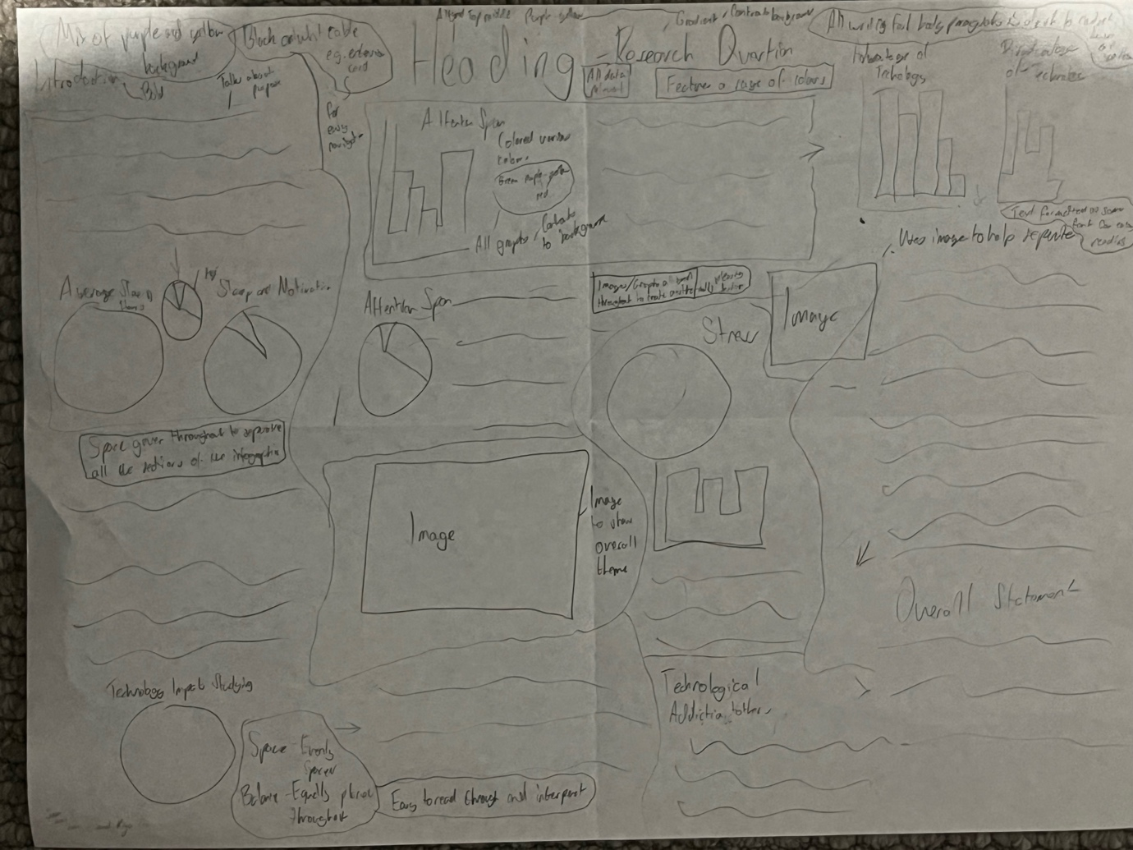

(I have the physical versions for both Software and Data if you’d rather look at those)